E-Commerce Customer Behavior & Churn Analysis :-
Subtitle
Analyzing Customer Retention, Engagement, Churn, and Revenue Drivers
Project Objective
This project analyzes customer behavior data from an e-commerce platform to identify key drivers of customer churn, engagement, and revenue. The goal was to uncover actionable business insights and build an interactive dashboard for decision-making.
Data Preparation :-
Tools Used
Python
- Handled missing values
- Checked duplicates
- Cleaned data types
- Exported cleaned dataset
SQL Server
- Imported cleaned dataset
- Performed KPI analysis
- Conducted churn, engagement, and revenue analysis
Power BI
- Created an interactive dashboard
- Built DAX measures
- Developed customer segments and churn indicators
Workflow
Raw Dataset
↓
Python Data Cleaning
↓
SQL Server Analysis
↓
Power BI Dashboard
↓
Business Insights

Business Problem :-
The company wants to understand:
- Why customers churn
- Which customers generate the most revenue
- What drives engagement
- Which countries contribute the most value
- How customer segments differ
Goals
✓ Reduce customer churn
✓ Improve customer engagement
✓ Increase customer lifetime value
✓ Identify high-value customer groups
Dataset Summary
Metric | Value
Total Customers | 50,000
Active Customers | 36,000
Churned Customers | 14,000
Churn Rate | 28.9%
Countries | 8
Customer Segments | High, Medium, Low
Fields Used
- Age Group
- Gender
- Country
- Customer Segment
- Lifetime Value
- Order Value
- Login Frequency
- Session Duration
- Mobile App Usage
- Email Open Rate
- Cart Abandonment Rate
- Executive Overview :-
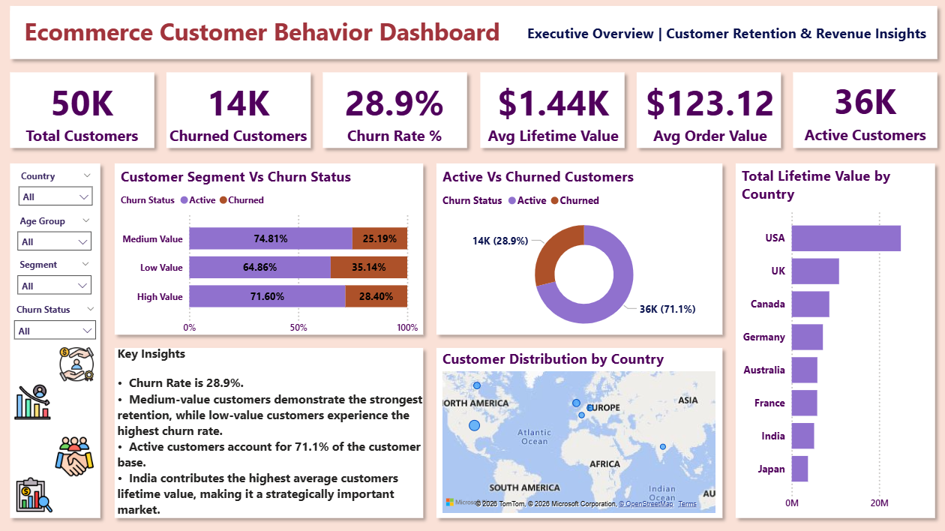
Key Findings
- Overall churn rate is 28.9%.
- Active customers account for 71.1% of the customer base.
- Medium-value customers demonstrate the strongest retention.
- India contributes the highest average customer lifetime value.
- Low-value customers experience the highest churn rate.
Business Impact
 Understanding these patterns helps prioritize retention efforts and customer value optimization.
- Customer retention is generally strong, but nearly 29% churn still causes notable revenue loss.

- Churn Analysis :-
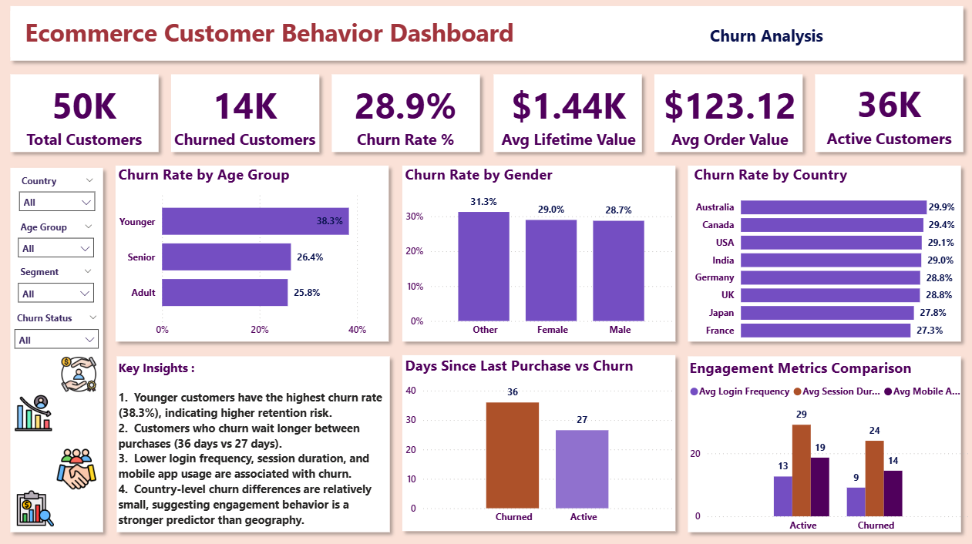
Key Findings
- Younger customers show the highest churn rate (38.3%).
- Churned customers wait longer between purchases.
- Engagement metrics are lower among churned customers.
- Country-level churn differences are relatively small.
Business Impact
- Younger customers are the highest-risk segment.
- Delayed purchases are a leading indicator of churn.
- Early intervention programs can reduce customer loss

- Customer Engagement Analysis :-
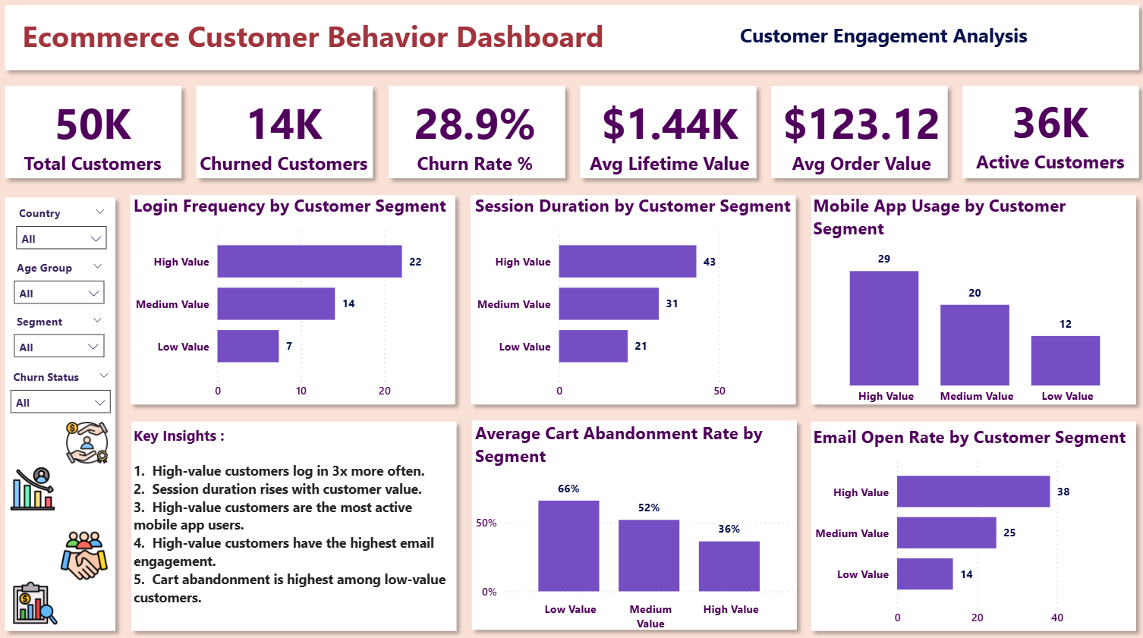
Key Findings
- High-value customers log in 3x more often.
- Session duration increases with customer value.
- Mobile app usage is highest among high-value customers.
- Email engagement is strongest among high-value customers.
- Cart abandonment is highest among low-value customers.
Recommendations
- Encourage app adoption.
- Improve email marketing personalization.
- Reduce cart abandonment through reminders and incentives.
- Customer engagement metrics strongly correlate with customer value.
- Improving app adoption and session activity can increase retention and revenue.

- Revenue & Customer Value Analysis :-
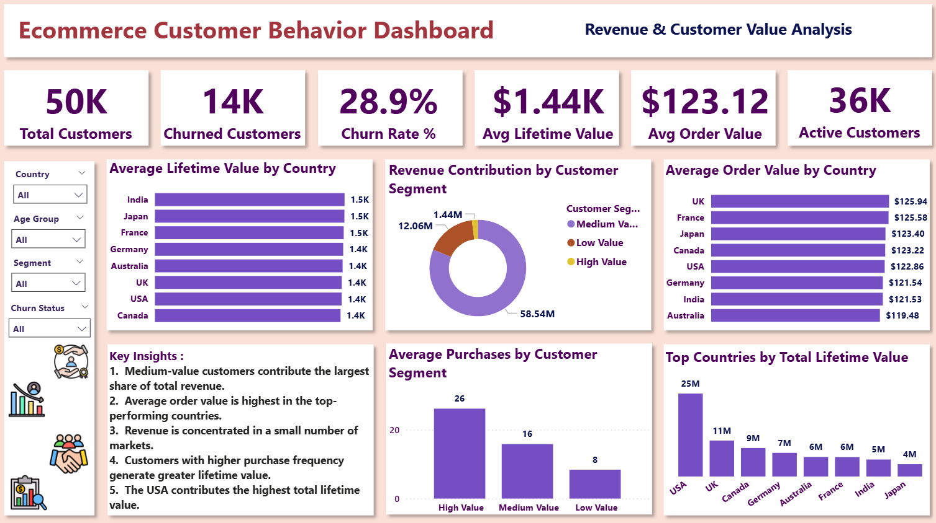
Key Findings
- Medium-value customers contribute the largest share of revenue.
- High-value customers purchase more frequently.
- Revenue is concentrated among a few countries.
- USA contributes the highest total lifetime value.
- Top-performing countries also have higher order values.
Recommendations
- Invest in high-performing markets.
- Upsell medium-value customers.
- Create loyalty programs for high-value customers.
- Medium-value customers represent the largest revenue opportunity due to their scale.
- Revenue concentration indicates dependency on a small number of markets.

***Overall Business Recommendations***
Customer Retention
- Target younger customers with retention campaigns.
- Identify inactivity early and trigger engagement actions.
Customer Engagement
- Promote mobile app usage.
- Increase email personalization.
Revenue Growth
- Upsell medium-value customers.
- Reward high-value customers.
- Focus marketing spend on top-performing countries.
***Conclusion***
Final Takeaways
This analysis revealed that:
- Customer engagement strongly influences retention.
- High-value customers exhibit better behavioral metrics.
- Medium-value customers drive most revenue.
- Younger customers are at higher risk of churn.
- Revenue opportunities exist through targeted retention and engagement strategies.

